Low Level Design (add Asset module)

|  |  |
| --- | --- |
| **Project Code** | Group 2 |
| **Project Name** | E-Commerce(Online Shopping) |

|  |  |  |
| --- | --- | --- |
| **Prepared/Modified by** | **Role** | **Date of Preparation** |
| Nidhi Shetty | Software Engineer | 16/12/2013 |
| **Reviewed by** | **Role** | **Date of Review** |
| Mrunalee Kothari | Software Engineer | 17/12/2013 |
| **Approved by** | **Role** | **Date of Approval** |
| Uma M Ponniamman | Training Manager |  |
| **Circulation List** | amit.agarwal@igate.com, mrunalee.kothari@igate.com, keerthi.parthasarathy@igate.com, nidhi.shetty@igate.com, nikeeta.menon@igate.com, shrikant.sutar@igate.com, bhagyashree.vedpathak@igate.com | **Version Number of the template:1.0** |
| **Version Number** | 1.3 |  |

Table of Contents

1. Description Of The Unit 3

2. References 4

3. Dependencies / Assumptions 5

4. Class Diagrams 6

5. Sequence Diagrams 7

6. Design Components 8

6.1 List Of UI Components 8

6.2 List Of Design Classes 8

7. Re-Usable Routines/Components 9

8. Messages 10

9. Configuration Files 11

10. Crud Matrix Table 12

11. Data Mapping Matrix 13

12. Action Flow Matrix 14

13. Stored Procedures 15

14. Program Specification / Pseudo Code 16

REVISION HISTORY OF THE WORK PRODUCT 17

# Description Of The Unit

The Update module allows the admin to update information about an existing asset.

The admin will be able to change the following data only

1. Asset Name
2. Asset Description
3. Asset Quantity
4. Asset Status

The admin will get the list of assets and beside that particular asset a modify link will be available clicking on which admin will modify that particular asset only.

# References

| **Reference** | **Description** |
| --- | --- |
| Class Diagram | /Project Documents/Design Documents/HLD/Class Diagrams |
| URS | /Project Documents/Requirements/Case Study/Group-2-Asset Management System.docx |
| UTP | /Project Documents/Test Plan/UTP/Test Cases/UpdateAsset /UTP_UpdateAssetModule.xlsm |
| DB Design | /Project Documents/Design Documents/HLD/DB Design/.xls |

# Dependencies / Assumptions

**Dependencies:**

The admin should be logged in.

**Assumptions:**

The admin details are stored in the database.

The asset details are also stored in database

# Class Diagrams

[Class Diagram](../../HLD/Class%20Diagrams)

# Design Components

## List Of UI Components

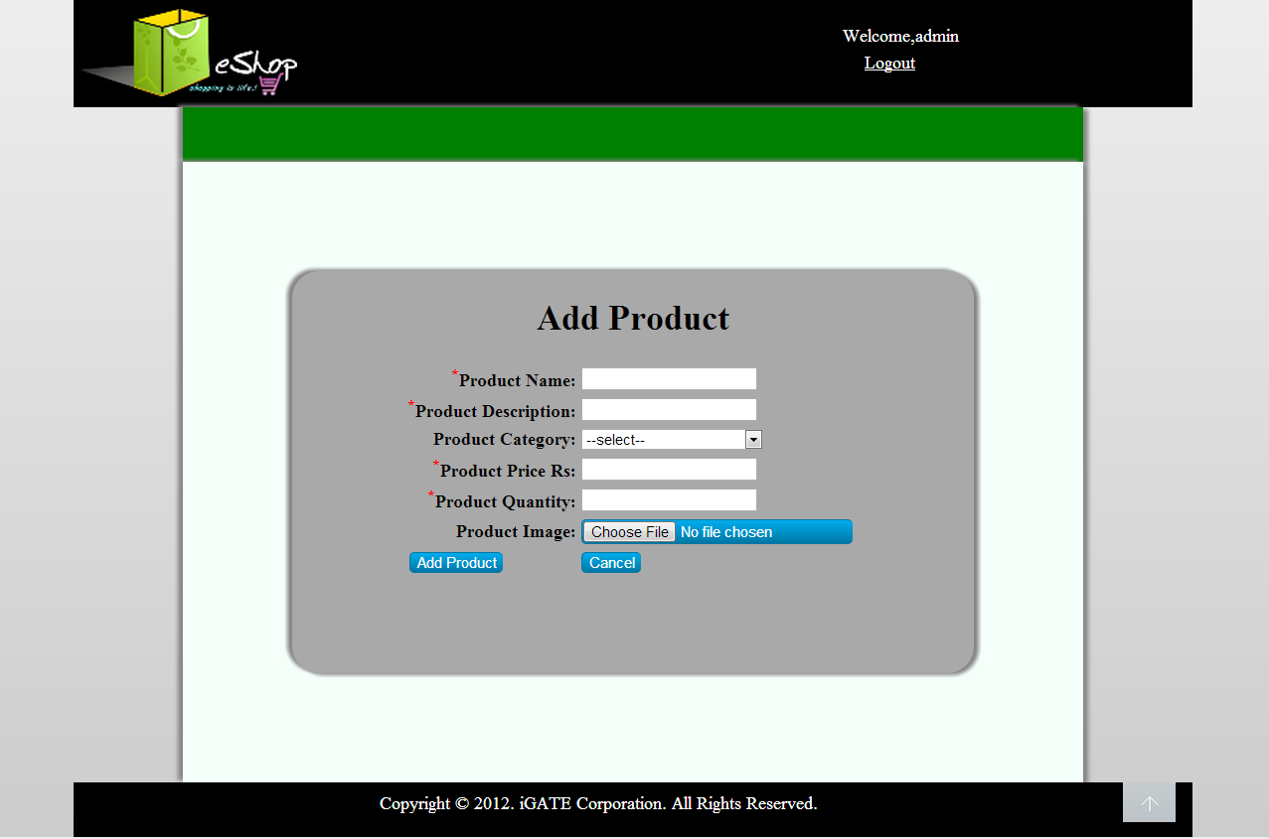

## List Of Design Classes

|  |  |  |  |  |
| --- | --- | --- | --- | --- |
| **Sr. No.** | **LLD Name** | **Class Name** | **Method Name** | **Method Description** |
| 1 | Update Asset Module | Asset | Appropriate getters and setters methods | Getters retrieve the property values and setters set the property values |
| 2 | Update Asset Module | MainController |  | Calls the method which will list the assets with modify button beside each asset. When admin clicks the modify button he will get form from which he would be able to update asset details. |
| 3 | Update Asset Module | AdminServiceImpl |  | Calls getSubCategoryList() of EshopDAOImpl class and returns the result to controller.  Calls addProduct():() of EshopDAOImpl class and returns the result to controller. |
| 4 | Update Asset Module | AdminDaoImpl |  | Retrieves the list of subcategories from the database and stores in a list.  Inserts the product details into the database and returns the result to EcommerceServiceImplementation. |

# Re-Usable Routines/Components

Re-Usable Routines/Components

* CSS files
* AdminException class
* ManagerException class
* Logger properties files

# Messages

|  |  |  |
| --- | --- | --- |
| **#.** | **Type** | **Message Text** |
| M1 | Error | Asset Name can contain letters , numbers and – and _ Only |
| M2 | Error | Asset description can contain letters , numbers and – and _ Only |
| M3 | Error | Please enter a quantity which is greater than 0 |
| M4 | Error | All fields are mandatory |

# Configuration Files

|  |  |  |
| --- | --- | --- |
| File Name | Path | Description |
| Web.xml | /Development/Source | To configure the spring API and giving dispatcher servlet info |
| Dispatcher-servlet.xml | /Development/Source | To configure the request mapping ,view resolver, look for beans , look for data source to connect to the database, to give location of controller, handle transactions |

# Crud Matrix Table

|  |  |  |  |  |  |
| --- | --- | --- | --- | --- | --- |
| **#** | **Table Name** | **Create** | **Read** | **Update** | **Delete** |
| 1. | Asset | Y | Y | Y | N |
| 2. | Asset_Allocation | N | N | Y | N |
| 3. | Department | N | N | N | N |
| 4. | Employee | N | Y | N | N |
| 5. | Request | Y | Y | Y | Y |
| 6. | User_Master | N | Y | N | N |

# Data Mapping Matrix

|  |  |  |  |  |  |  |  |
| --- | --- | --- | --- | --- | --- | --- | --- |
| **Sr. No.** | **Screen Label** | **Field Source** | **Field Type** | **Data Type** | **Max Length** | **Data Flow** | **Mandatory** |
| 1 | Asset Id | Sequence Generated | TextBox (Read Only) | Number | NA | D🡪UI | Yes |
| 2 | Asset Name | Asset_Name | TextBox | Varchar2 | 15 | UI🡪D | Yes |
| 3 | Asset Description | AssetDes | TextBox | Varchar2 | 25 | UI🡪D | Yes |
| 4 | Asset Quantity | Quantity | TextBox | Number | NA | UI🡪D | Yes |
| 5 | Status | Status | Dropdown | Varchar2 | 15 | UI🡪D | Yes |
| 6 | Modify | NA | Button | NA | NA | UI | NA |
| 7. | Reset | NA | Button | NA | NA | UI | NA |

**Legend**

D 🡪 UI (Database to User Interface)

UI 🡪 D (User Interface to Database)

UI (User Interface Only)

# Action Flow Matrix

|  |  |  |  |
| --- | --- | --- | --- |
| **Sr. No.** | **Action** | **Description** | **Process** |
| 1 | On click of modify asset link | Redirected to the asset list page | The admin clicks on the modify link in the admin homepage and gets redirected to the list asset page. |
| 2 | On click of modify link | The admin is redirected to modify form page | Data is entered in the fields by the admin which gets inserted into the database when Modify button is pressed. |
| 3 | On click of Reset button in Modify page | The asset is not modified into the database. | When reset button is clicked all fields get reseted |

# Stored Procedures

|  |  |  |  |  |
| --- | --- | --- | --- | --- |
| **#** | **Stored Procedure Name**  **(with Description)** | **Input/Out Parameters** | **Type** | **Size** |
| 1. | NA | NA | NA | NA |

# Program Specification / Pseudo Code

## <ACTION :CLICK_MODIFYLINK>

**Pseudo Code:**

1. **Client Side Scripting:**

None

1. **Server Side Scripting:**

**BEGIN**

Call in Controller class

Navigate to List Asset Page

**END**

**14. 2 <ACTION: CLICK MODIFY LINK>**

**Pseudo Code:**

1. **Client Side Scripting:**

IF invalid Asset Name

Print Error Message M1

IF Asset Name isEmpty

Print Error Message M4

IF invalid Asset Description

Print Error Message M2

IF Asset Description isEmpty

Print Error Message M4

IF Asset Quantity isEmpty

Print Error Message M4

‘

IF invalid Asset Quantity

Print Error Message M3

1. **Server Side Scripting:**

**BEGIN**

Call processModifyAssetPage(@RequestParam("assetId") String assetId, @RequestParam("assetName") , @RequestParam("assetDes") , @RequestParam("Quantity"),@RequestParam("Status") @ModelAttribute("Asset") @Valid Asset product,BindingResult result,Model model) in Controller class in Presentation Layer

**BEGIN**

Call Boolean modifyAsset(Asset asset) from Service Layer object in controller

**BEGIN**

Call Boolean modifyAsset (Asset asset) in AdminDAOImpl class ,in Data Access Layer

**BEGIN**

Create a query which will take all the details from form and insert the updated details into the database

Return true

**END**

Return true to Service Layer

**END**

Return true to controller

**END**

IF successful navigate to viewAssets page

Else navigate to modify page and show error.

**END**

REVISION HISTORY OF THE WORK PRODUCT

|  |  |  |  |  |  |
| --- | --- | --- | --- | --- | --- |
| # | Date | Version # | Section Changed | Details of changes made | Approved By |
| 1 | 06/04/2017 | 1.0 | LLD prepared | N/A |  |
| 2 |  |  |  |  |  |
| 3 |  |  |  |  |  |
| 4 |  |  |  |  |  |